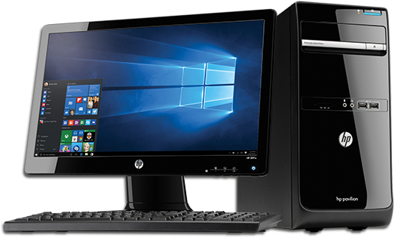


To implement a set of iPads to begin using Microsoft Sway and AI to support learning.
To implement understanding of AI into the curriculum, to ensure children and staff use it appropriate and safely, including lessons centred around awareness of the link between Fake News and AI.
To embed the changes made to the provision and assessment of reading, writing, maths and the wider curriculum to ensure that children know and remember more and have improved outcomes for the next stage of their education.
To embed the culture of safeguarding and ensure pupils are ready for the next stage of their education.
To ensure Computing is inclusive by design — enabling every learner (including those who are disadvantaged, with SEND, EAL, protected characteristics, etc.) to fully participate, achieve and feel a sense of belonging in lessons.
To ensure pupils acquire, retain, and apply key knowledge across the curriculum, enabling them to make sustained progress and achieve well.
Computing Pictorial summary 2025 2026

