Ferris wheel facts for kids
Kids Encyclopedia Facts

A Ferris wheel on the boardwalk in Ocean City, New Jersey, US
A Ferris wheel (sometimes called a big wheel, observation wheel, or, in the case of the very tallest examples, giant wheel) is a nonbuilding structure consisting of a rotating upright wheel with multiple passenger-carrying components (commonly referred to as passenger cars, cabins, tubs, capsules, gondolas, or pods) attached to the rim in such a way that as the wheel turns, they are kept upright, usually by gravity.
Some of the largest modern Ferris wheels have cars mounted on the outside of the rim, with electric motors to independently rotate each car to keep it upright. These wheels are sometimes referred to as observation wheels and their cars referred to as capsules, however these alternative names are also used for wheels with conventional gravity-oriented cars.
The original Ferris Wheel was designed and constructed by George Washington Gale Ferris Jr. as a landmark for the 1893 World's Columbian Exposition in Chicago. The generic term Ferris wheel is now used for all such structures, which have become the most common type of amusement ride at state fairs in the United States.
Since the original 1893 Chicago Ferris wheel there have been nine world's tallest-ever Ferris wheels. The current record holder is the 167.6-metre (550 ft) High Roller in Las Vegas, US, which opened to the public in March 2014.

Observation wheels
Observation wheel is an alternative name for Ferris wheel. In 1892, when the incorporation papers for the Ferris Wheel Company (constructors of the original 1893 Chicago Ferris Wheel) were filed, the purpose of the company was stated as: [construction and operation of] "...wheels of the Ferris or other types for the purpose of observation or amusement".
Some Ferris wheels are marketed as observation wheels, any distinction between the two names being at the discretion of the operator, however the wheels whose operators reject the term Ferris wheel are often those having most in common with the original 1893 Chicago Ferris Wheel, especially in terms of scale and being an iconic landmark for a city or event.
Wheels with passenger cars mounted external to the rim and independently rotated by electric motors, as opposed to wheels with cars suspended from the rim and kept upright by gravity, are those most commonly referred to as observation wheels, and their cars are often referred to as capsules. However, these alternative names are also sometimes used for wheels with conventional gravity-oriented cars.
Only four Ferris wheels with motorised capsules have ever been built.
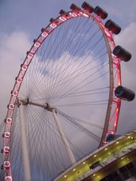 | 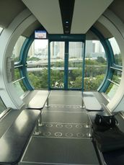
The Singapore Flyer has 28 cylindrical air-conditioned passenger capsules, each able to carry 28 people

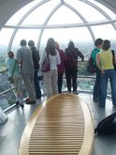 | 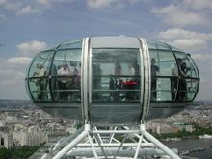
The London Eye's 32 ovoidal air-conditioned passenger capsules each weigh 10 tonnes (11 short tons) and can carry 25 people
The 167.6 m (550 ft) High Roller, world's tallest since March 2014, has externally mounted motorised capsules of a transparent spherical design, and is described as both a Ferris wheel and an observation wheel by the media.
The 165 m (541 ft) Singapore Flyer has cylindrical externally mounted motorised capsules and is described as an observation wheel by its operators, but was also credited as "world's largest Ferris wheel" by the media when it opened in 2008.
The 135 m (443 ft) London Eye, typically described as a "giant Ferris wheel" by the media, has ovoidal externally mounted motorised capsules and is the "world's tallest cantilevered observation wheel" according to its operators, who claim "The London Eye is often mistakenly called a Ferris wheel. This is not the case: first, the passenger capsules are completely enclosed and are climate controlled; secondly, the capsules are positioned on the outside of the wheel structure and are fully motorised; and third, the entire structure is supported by an A-frame on one side only." However the Singapore Flyer subsequently billed itself as the "world's largest observation wheel", despite being supported on both sides, and the official londoneye.com website also refers to the London Eye as "Europe's tallest Ferris wheel".

The 120 m (394 ft) Melbourne Star (previously the Southern Star) in Australia has ovoidal externally mounted motorised capsules and is described by its operators as "the only observation wheel in the southern hemisphere", but also as a Ferris wheel by the media.
Official conceptual renderings of the proposed 190.5 m (625 ft) New York Wheel, due to begin construction in 2015, also show a wheel equipped with externally mounted motorised capsules.

