Working Towards the Expected Standard
Use conjunctions, adverbs and prepositions to express time, place or cause. | 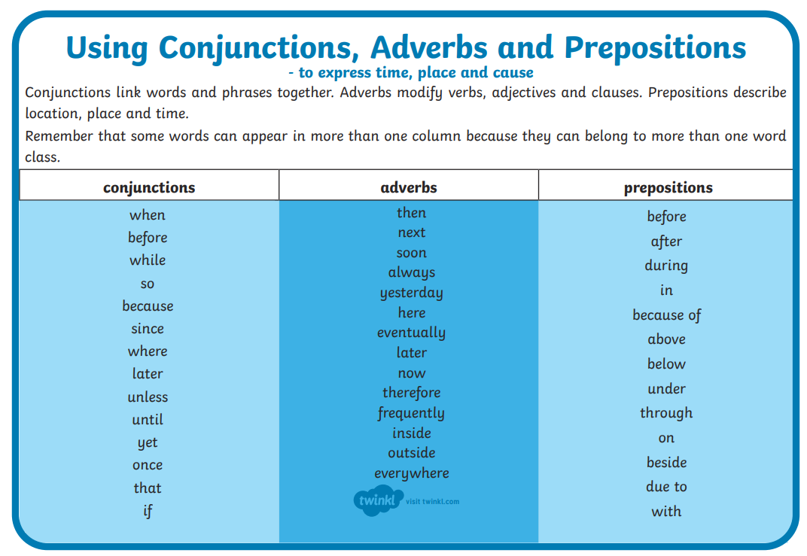
use the present perfect form of verbs in contrast to the simple past tense | This is the ride you have been waiting for!  Ever since it opened 4 years ago, thrill-seekers have been raving about this ride and travelling from all over the world just to experience its speed and G-force.
CL FS ? ! used correctly
Commas after fronted adverbials | Before your heart rate even has a chance to settle down, this ride begins its second lap of torture.  Breathlessly, Alan Michaels – who is a professional rider – exclaimed that this was the best ride he had ever been on.  Shockingly, this speed demon goes from 0mph to 120mph in just 8 seconds!  Right in the middle of the theme park, you will see the intimidating Apocalpyse towering above the rest.  In just 2 seconds, you heart will leave your chest faster than a scream can leave your mouth.
Working at the Expected Standard
Describe settings, characters and atmosphere. |  |  | The deep bass and electric lights will make you feel like you’re on another planet.
I can integrate dialogue to convey a character’s thoughts and feelings.
use paragraphs to organise information and ideas around a theme |  |  | Introduction  General description  Special features  Effect on the rider  Persuasive conclusion (including a slogan)
use adverbials of time, place and number to link ideas across paragraphs |  |  | 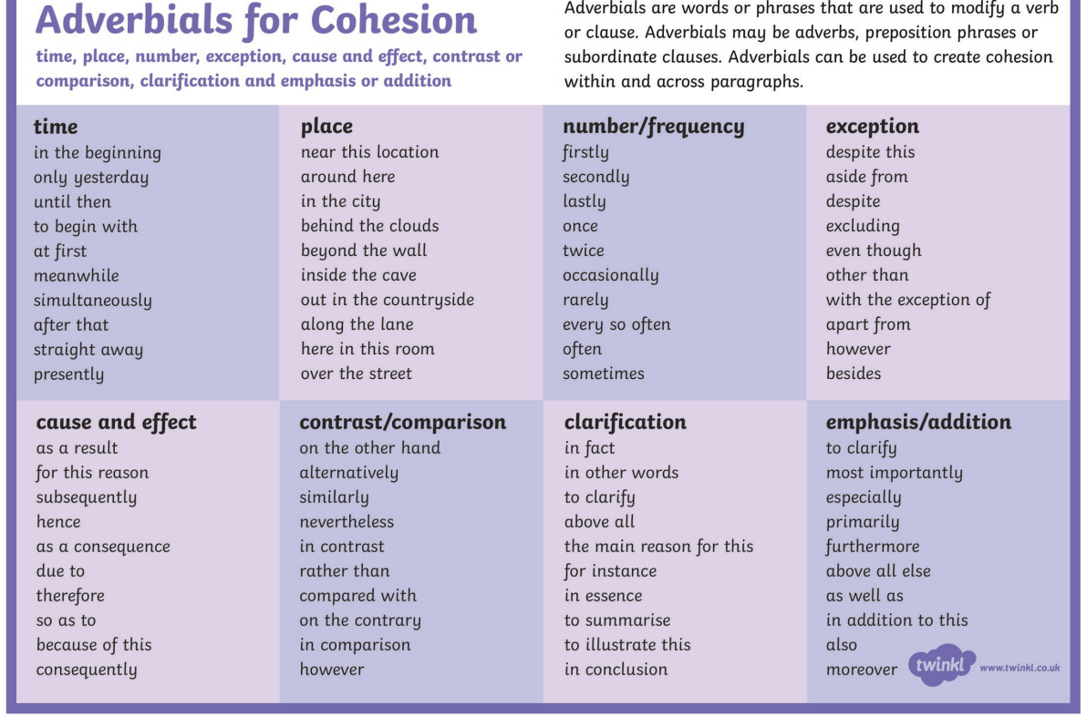  This ride will make you immediately regret all of your decisions.  This beast is already the top rated roller coaster in the world even though it only launched 2 years ago!  As a result of the newest technology, Apocalypse is one-of-a-kind and you will never experience anything like it.
choose pronouns and nouns to aid cohesion and clarity and to avoid repetition |  |  | He/her/she/him/they…
use devices to build cohesion within a paragraph (e.g. then, after that, this, firstly) |  |  | 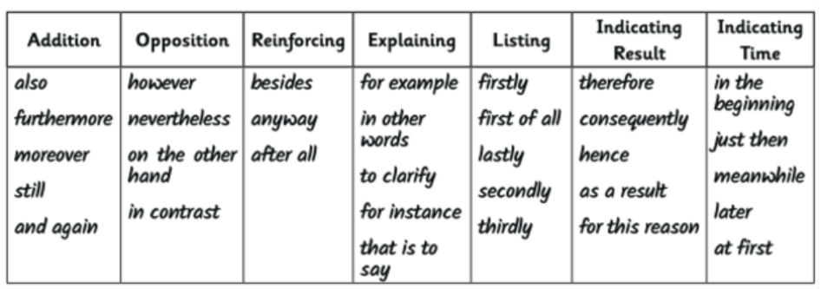  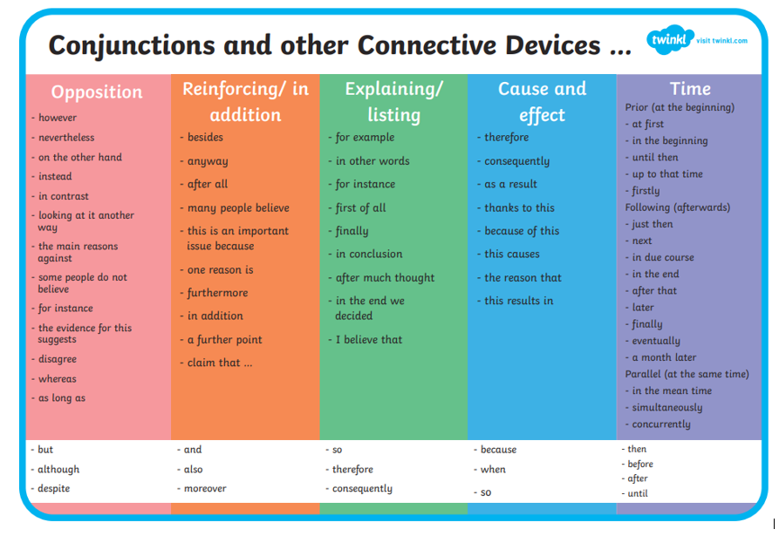
use correct subject and verb agreement throughout a piece of writing
Use standard English forms for verb inflections
use nouns and noun phrases modified by preposition phrases to expand and develop ideas, information and description |  |  | Expanded noun phrase + a preposition.  Beneath the galactic, mysterious dome, you will find the entrance to the ride of your life.  The unique, thrilling Apocalypse can be found next to …  Top sound systems are placed between the comfy, protective seats.  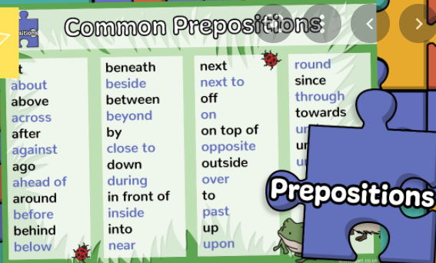  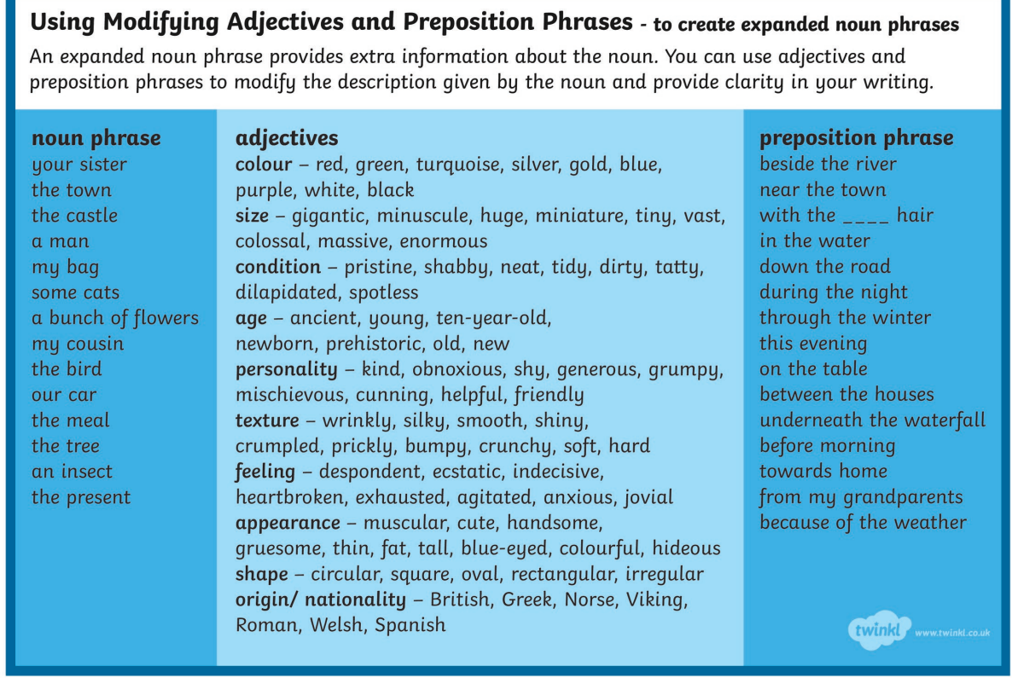
indicate degrees of possibility using adverbs (for example, perhaps, surely) or modal verbs (for example, might, should, will, must) |  |  | This is certainly the ride that every thrill-seeker in the world wants to ride.  Surely you don’t want to miss out of the opportunity for the excitement of your life?
use fronted adverbials to vary sentence structure |  |  | 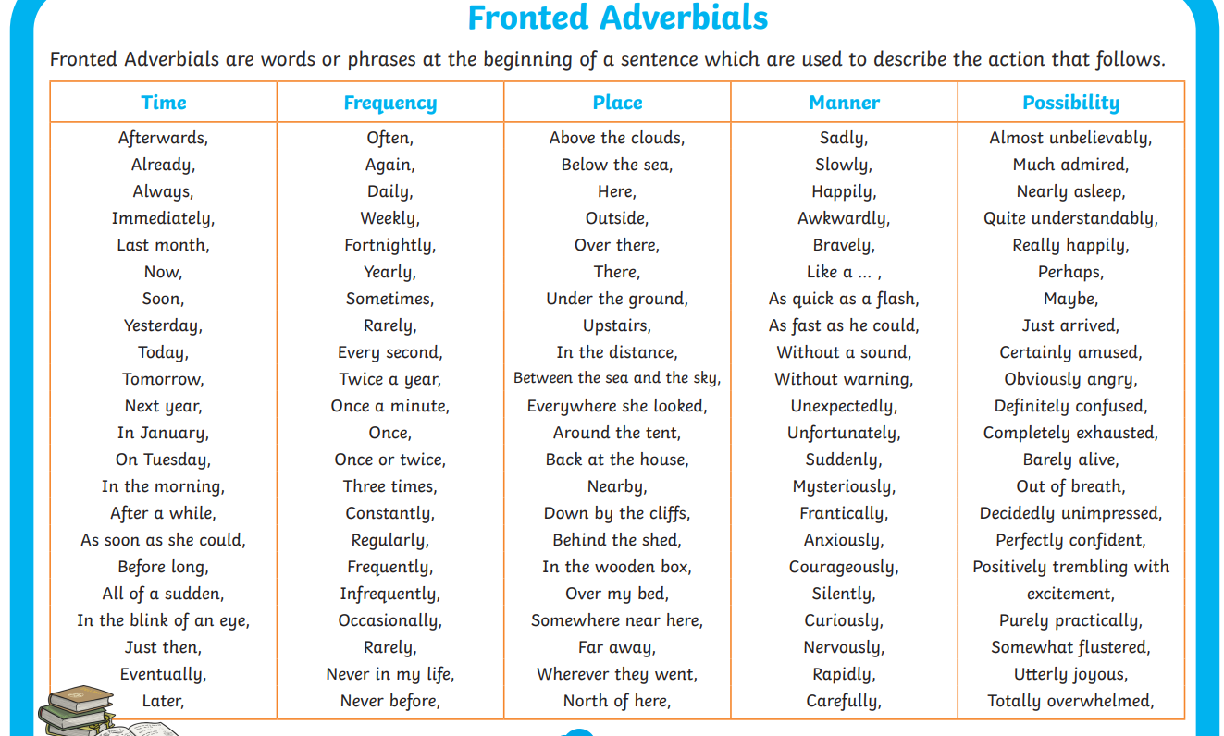
use relative clauses beginning with who, which and that (or an omitted relative pronoun) to add detail and description |  |  | Apocalypse, which was built in 2002, ….  Matt Helix – who is the world’s bravest man - ….  The seats (which have been designed with safety in mind) …
Use mostly correctly |  | CL FS ? !
 |  | Apostrophes to mark singular and plural possession | The rider’s heart rate.
 |  | brackets, dashes or commas to indicate parenthesis | Speed demons (like you) would never miss out on the chance to increase their heart rate like never before!
 |  | punctuation for direct speech including a comma after the reporting clause, and end punctuation within inverted commas
 |  | use of commas to clarify meaning or avoid ambiguity
Accurately spell most prefixes and suffixes for Y5/6 |  |  | -ous serious, courageous  -ly desperately, bravely,  -tion
Spelling most of the words from the Y3/4 spelling list and half of the words on the Y5/6 spelling list |  |  | 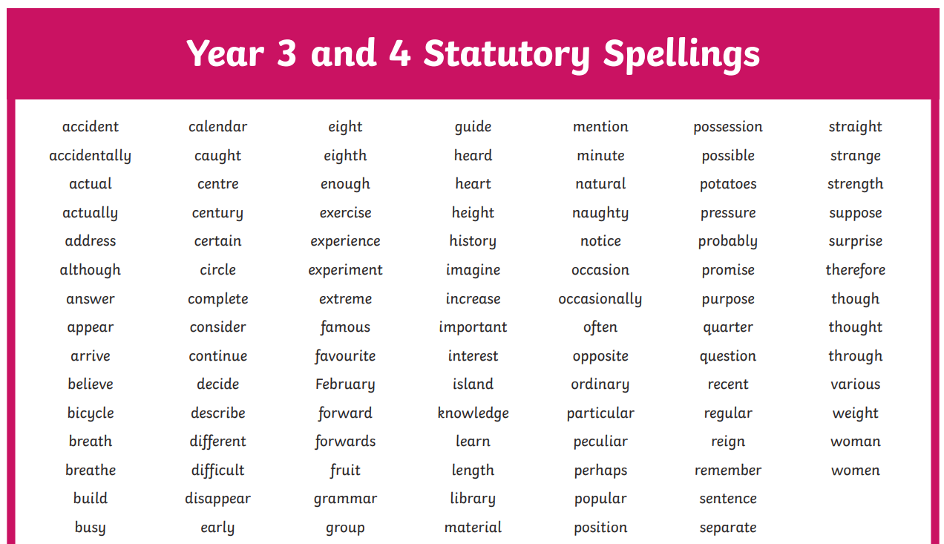
Accurately spelling of most homophones and other words which are often confused |  |  | Which  Your / you’re  There / their / they’re  Who / how  Where / were / we’re
Working at Greater Depth
Changes to vocabulary, grammar and punctuation, including use of tense.
Use and apply adventurous vocabulary
using a wide range of clause structures, sometimes varying their position within the sentence
using adverbs, preposition phrases and expanded noun phrases effectively to add detail, qualification and precision
Use sometimes | Hyphens
 | Dashes
 | Semi colons in a list
 | Colons
Spell most the Y5/6 words correctly. |  |  | 