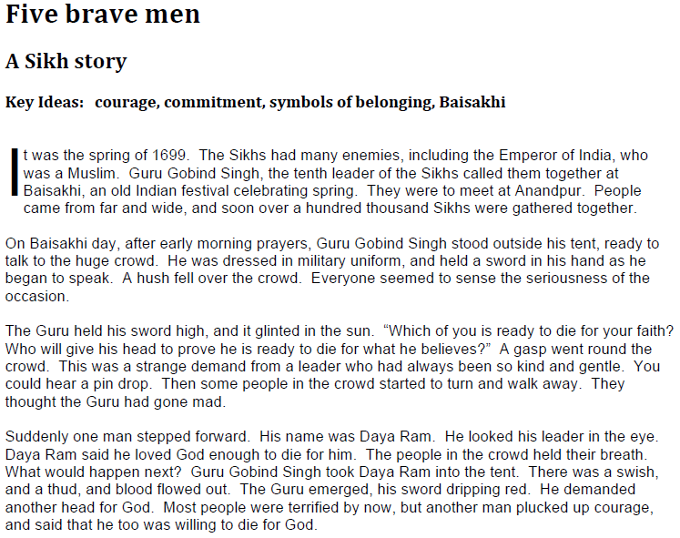

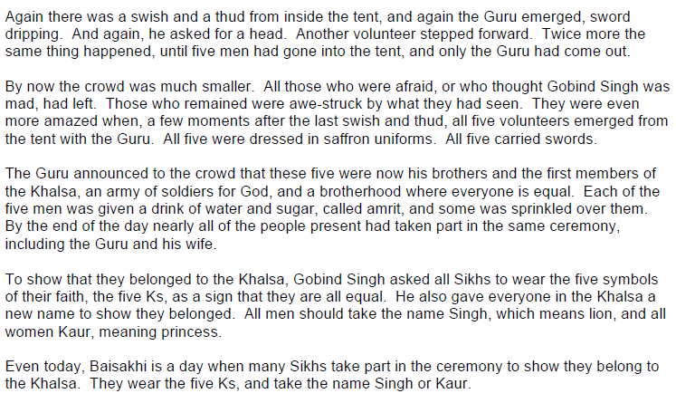

https://www.bbc.co.uk/programmes/p02mx69p

Watch video and answer following questions:

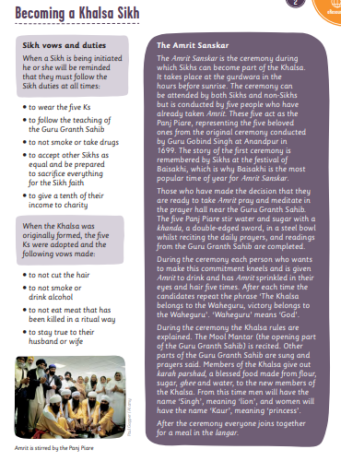

Use this information to write a diary entry as though you are watching a friend be initiated into the Sikh Khalsa.

What is it like?
How do you feel?
How do they feel?

