The Quarrel  By Maxine Kumin | 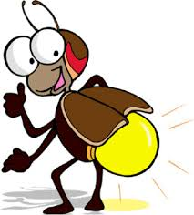
Said a lightning bug to a firefly,
"Look at the lightning bugs fly by!"

"Silly dunce!" said the fly. "What bug ever flew?
Those are fireflies. And so are you."

"Bug!" cried the bug. "Fly!" cried the fly.
"Wait!" said a glowworm happening by.

"I'm a worm," squirmed the worm. "I glimmer all night.
You are worms, both of you. I know that I'm right."

"Fly!" cried the fly. "Worm!" cried the worm.
"Bug!" cried the bug. "I'm standing firm!"

Back and forth through the dark each shouted his word
Till their quarrel awakened the early bird.

"You three noisy things, you are all related,"
She said to the worm, and promptly ate it.

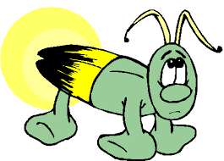
With a snap of her bill she finished the fly,
And the lightning bug was the last to die.

All glowers and glimmerers, there's a MORAL:
Shine if you must, but do not quarrel

