Pencil holder dimensions

Original 3D object

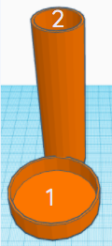

Cylinder 1
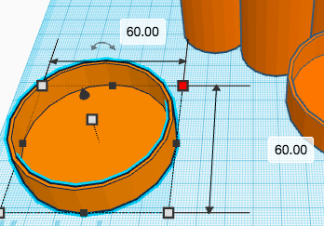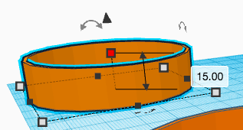

Cylinder 2
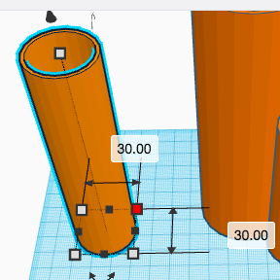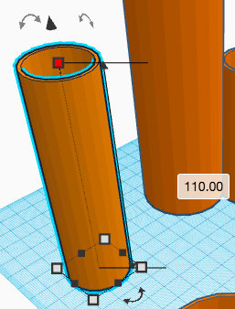

This resource is available online at ncce.io/cm6m-4-a2-rp. Resources are updated regularly — please check that you are using the latest version.

This resource is licensed under the Open Government Licence, version 3. For more information on this licence, see ncce.io/ogl.

