Wrockwardine Wood CE Junior School

INCLUDEPICTURE "https://www.wrockwardinewoodjunior.org.uk/wp-content/themes/kiskadoo_responsive2/images/logo.png" \* MERGEFORMATINET INCLUDEPICTURE "https://www.wrockwardinewoodjunior.org.uk/wp-content/themes/kiskadoo_responsive2/images/logo.png" \* MERGEFORMATINET INCLUDEPICTURE "https://www.wrockwardinewoodjunior.org.uk/wp-content/themes/kiskadoo_responsive2/images/logo.png" \* MERGEFORMATINET INCLUDEPICTURE "https://www.wrockwardinewoodjunior.org.uk/wp-content/themes/kiskadoo_responsive2/images/logo.png" \* MERGEFORMATINET 

Special Educational Needs and Disability Policy

Date policy amended September 2024
Next review date September 2025

Reviewed annually by the Governing Body
Vision Statement

- “Love, Laugh Learn”
- We will ignite the ability in all to ‘Love, Laugh and Learn’, recognising the extraordinary and wondrous in everything and in everyone. Our rich, varied and creative curriculum, together with our Christian values, will empower all to flourish following Jesus’s promise ‘I have come to give life and life in all its fullness.’ (John 10:10)


- Our School Christian Values





Aims
The aims of our Special Needs and Disability Policy are-:
- To provide information to governors, teachers, support staff and parents about the school’s philosophy and practice in relation to pupils with Special Educational Needs.
- To clarify the roles and responsibilities of Teachers, Teaching Assistants and the Special Educational Needs and Disability co-ordinator (SENDCo).
- To give practical guidelines on the processes of identification, monitoring and review in line with the graduated response outlined in the Code of Practice, January 2015.

General statements of intent
Our school gives children with Special Educational Needs and/or Disabilities high priority in terms of development and pupil attainment.

All of our teachers are teachers of children with Special Educational Needs and/or Disabilities and have a responsibility to meet those needs with the advice and support of the SENDCo and external professionals as appropriate.

Our school offers equal opportunities to all pupils. All of our pupils are entitled to a broad, balanced and relevant curriculum, which includes the National Curriculum.

Pupils with a disability will not be treated less favourably and reasonable steps will be taken to ensure access to the school areas and to the curriculum. (Special Educational Needs and Disability Regulations 2014)

Our pupils with Special Educational Needs and/or Disabilities are fully integrated into all aspects of the school life.

Our pupils’ Special Educational Needs and/or Disabilities will be identified as early as possible. We recognise that these needs will change. They will be closely monitored using a graduated response. Children will therefore move in both directions through the graduated response.

We want all pupils to develop a positive attitude to themselves as learners and to reach their potential.

The school works in partnership with all parents.

The views of the pupil are sought and taken into account in all decision making processes when appropriate.

The development and management of Special Educational Needs and Disabilities is incorporated into the School Development Plan.

Legislation and guidance

This policy and information report is based on the statutory Special Educational Needs and Disability (SEND) Code of Practice and the following legislation:
- Part 3 of the Children and Families Act 2014, which sets out schools’ responsibilities for pupils with SEND and disabilities
- The Special Educational Needs and Disability Regulations 2014, which set out schools’ responsibilities for education, health and care (EHC) plans, SEND co-ordinators (SENDCOs) and the SEND information report.

Definition

Children have Special Educational Need if they have a learning difficulty or disability which calls for Special Educational Provision to be made for them.
Children have a learning difficulty or disability if they (Code of Practice, 2015):
- Have a significantly greater difficulty in learning than the majority of children of the same age.
- They have a disability which prevents or hinders them from making use of educational facilities of a kind generally provided for children of the same age in schools within the area of the LEA.

Areas of Special Educational Need
Special Educational Needs and provision can be considered as falling under four broad areas:
- Communication and Interaction
- Cognition and Learning
- Social, Mental and Emotional Health
- Sensory and/or Physical

Many children have difficulties which fit clearly into one of these areas, some have needs which span two or more areas, for others the precise nature of their need may not be clear at the outset.

Special educational provision is educational or training provision that is additional to, or different from, that made generally for other children or young people of the same age by mainstream schools.

We recognise that gifted children may also have Special Educational Needs. (See policy for pupils who are gifted.)

Children will not be considered to have special educational needs by virtue of the fact that English is not their home language. If, however, there is evidence of learning difficulties when English has become established, the same graduated response will be made as for other children.

Most of our pupils, who experience special educational needs, are those with mild learning difficulties. These may be temporary, and with support, overcome. Their needs will be met from the school’s own learning support provision.

Over the past few years, we have seen an increase of children needing additional provision for Social, Emotional Mental Health, with a considerable percentage of these children having experienced adverse childhood experiences (ACEs). This could be for very many different reasons depending on their personal situation. For them, the complex activities and bustle of a large class can be overwhelming: listening to the class teacher, processing what the teacher says, can cause further distress, they could be easily distracted and quickly feel defeated. Some withdraw; others express their frustration by aggressive or impulsive behaviour conflicting from their chronological age. At school we assess children who are displaying Social, Emotional or Mental Health difficulties through the Boxall Profile.
Children who are considered to be at risk from social, emotion and mental health difficulties are immersed in a nurturing environment where their learning is understood developmentally; the classroom offers a safe base; the importance of nurture for the development of wellbeing is understood as a priority; understanding that language is a vital means of communication; all behaviour is communication and where the importance of transition in the lives of children and young people is understood.

Funding

A few pupils will experience special educational difficulties that will require additional resourcing. These pupils will have an Education and Health Care Plan (EHCP) and the school will receive some additional resources to provide for these needs. Other children may access funding through the Inclusive Schools Forum (ISF).

The allocation of funding received for pupils who do not have an EHCP will be based on the response to their needs at the discretion of the governing body in collaboration with the Head and Special Educational Needs Co-ordinator.

Where it is felt that a child does not need an EHCP but may need access to some extra funding (additional to the £6000 notional budget), the SENDCo may consider an application to the Inclusive School Forum. The Inclusive School Forum is a school led forum within Telford and Wrekin that provides support and challenge to mainstream schools regarding the provision and practice provided.

Resources
There are substantial resources, including ICT, which are used in every classroom as part of our normal classroom practice. We also have additional resources used for interventions taking place outside the classroom such as:
- Talking postcards
- Sensory Diet resources
- Barrier games resources
- Speed up / Write from the start handwriting resources
- Dyscalculia resources
- Numicon Breaking Barriers
- Build to Express Lego
- TalkBoost

Special Educational Needs resources are held in the SENDCo’s office and on the computer in One Drive.

Allocation of Resources

- Equipment and other resources are available to all staff.
- TA time is allocated to the individual needs of children with an EHCP, ISF and those children with more complex needs
- TA time is allocated to work with pupils on specific programmes as required by the intervention timetable.
- TA time is allocated to assist the class teacher in meeting the Special Educational Needs of pupils within the class.

The allocation of funding received for pupils who do not have an EHCP or access to ISF will be based on a graduated approach to their needs at the discretion of the Headteacher and SENDCo. The school is allocated a specific allowance of money for SEND. Most of it is used to provide additional hours for the TAs as best to support the children through Quality First Teaching in the classroom.

Roles and responsibilities
The Head and the Governors, with the designated Special Educational Needs Governor, will be responsible for the management of Special Educational Needs provision. (Appendix 1)

The SENDCo for the year 2024-2025 is Alison Williams (01952 387880).

The key responsibilities of the SENDCO include:
- Work with the headteacher and SEN governor to determine the strategic development of the SEN policy and provision in the school
- Have day-to-day responsibility for the operation of this SEN policy and the co-ordination of specific provision made to support individual pupils with SEN, including those who have EHC plans
- Provide professional guidance to colleagues and work with staff, parents, and other agencies to ensure that pupils with SEN receive appropriate support and high quality teaching
- Advise on the graduated approach to providing SEN support
- Advise on the deployment of the school’s delegated budget and other resources to meet pupils’ needs effectively
- Be the point of contact for external agencies, especially the local authority and its support services
- Liaise with potential next providers of education to ensure pupils and their parents are informed about options and a smooth transition is planned
- Work with the headteacher and governing board to ensure that the school meets its responsibilities under the Equality Act 2010 with regard to reasonable adjustments and access arrangements
- Ensure the school keeps the records of all pupils with SEN up to date

The school will ensure that the SENDCO has sufficient time and resources to carry out these functions. This means our school SENDCo is non-teaching.

This will include providing the SENDCO with sufficient administrative support and time away from teaching to enable them to fulfil their responsibilities in a similar way to other important strategic roles within a school.

The SEND governor is Samantha Azzopardi-Tudor

The SEND governor will:
- Help to raise awareness of SEND issues at governing board meetings
- Monitor the quality and effectiveness of SEND and disability provision within the school and update the governing board on this
- Work with the headteacher and SENDCo to determine the strategic development of the SEN policy and provision in the school

The Headteacher
The Headteacher will:
- Work with the SENDCo and SEND governor to determine the strategic development of the SEND policy and provision in the school
- Have overall responsibility for the provision and progress of learners with SEN and/or a disability

The Class teacher is responsible for:
- Identifying children with Special Educational Needs.
- Assessing children’s needs and creating bespoke targets for the children’s interventions.
- Liaising closely with Teaching Assistants through effective communication.
- Planning and delivering a differentiated curriculum according to the needs of the children in their care.
- Monitoring progress.
- Discussing children’s progress with parents three times a year.
- Writing and evaluating provision maps alongside the SENDCo

The role of Teaching Assistants:
- To work as part of a team, supporting children with Special Educational Needs in school.
- To evaluate provision map targets for individual children
- To help the child with Special Educational Needs benefit from all the activities undertaken by the other children in the class, depending upon the difficulties experienced by the child.
- To support the delivery of the curriculum as requested by the teacher.
- To respond to tasks which they have supported in a way that informs future planning.
- To assist in producing support materials for the benefit of children with Special Educational Needs.
- To ensure a consistency of approach and methodology between the experiences offered by the class teacher.
- To support children within the classroom.
- To report any concerns they have about the children, their progress or their work to the class teacher, Special Educational Needs Co-ordinator or Head teacher as soon as possible.
- To monitor behaviour both inside school and as necessary outside school at playtime and record any incidents on CPOMs.
- To support the child as a member of a collaborative group and to help develop social and organisational skills
- There will be occasions when it is necessary for the Learning Support Assistant to attend CPD.

Identification, assessment, monitoring and review procedure

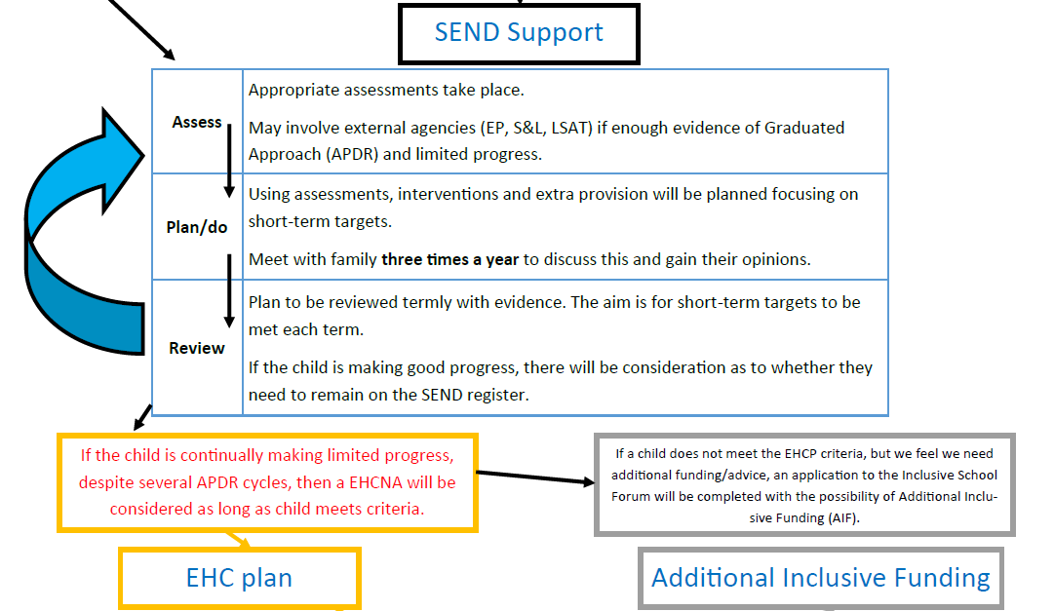
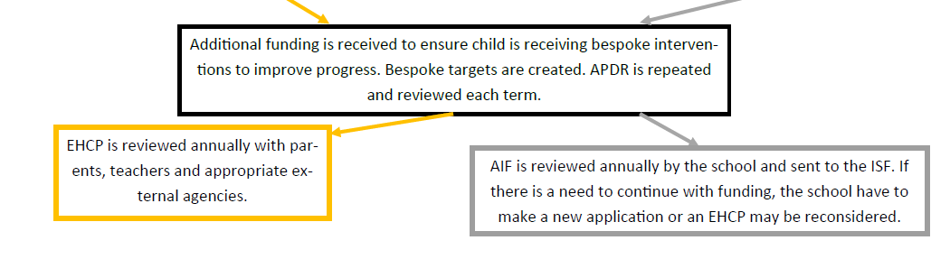

Staff Professional Development

The SENDCo attends appropriate courses to enable them to keep up-to-date with developments in Special Educational Needs.
The SENDCo attends a local SEND network meeting every term.
The TAs have participated in various training programmes and meet once a week to share knowledge and update training.
Special Needs are regular items on Teachers’ and TA Meetings’ agenda.
The SENDCo involves the Nominated Governor in matters arising from these.

Special Educational Needs partnerships

Partnership with Parents
We wish to work alongside parents to help their children.
We will discuss with parents the response to their child’s difficulties, the targets set and the provision given. This will be on Parents Evening, when the parent has been invited to school or wishes to make their own appointment. Parents are offered an additional Parents Evening in the spring term to discuss transition and targets.
The Information, Advice and Support Services (IASS) is an agency available to support parents whose child has special educational needs.

Pupils
From the start of intervention, pupils, who are capable of forming views are encouraged to give their opinions in the decision making processes for:-
- Setting learning targets and contributing to Provision Maps.
- Putting their views at the start of their Provision Maps
- The assessment of their needs.
- Being involved in transition planning and the choice of a new school.
- Contributing to the annual review.

Partnerships with Special Educational Needs Support Services
The school works closely with all agencies involved in supporting pupils. At present, sessions from the Educational Psychologists, Learning Support Advisory Teacher Team and Behavioural Support Team are purchased when necessary.

Other agencies which may be called upon for support/advice are The Speech and Language Therapy Service, The Occupational Therapy Service and the Sensory Inclusion Services, i.e. the hearing and visual impairment teams. Educational Welfare Officers and the School Nurse are involved when appropriate.

Partnership with other schools
Liaison with the secondary schools takes place during the Summer Term (or even earlier with children with an EHCP) to enable a smooth transition. The Special Educational Needs records are discussed and sent to the relevant schools. Parents are also invited along for a group meeting to ensure their views are listened to.

Year 3 teachers, along with the SENDCo, visit Wrockwardine Wood Infant School during the Summer term to meet the Year 2 children who will be transferring in the Autumn. The SENDCO and Pastoral Lead also attend any relevant Early Help meetings for SEND children in the summer term. Children with special needs are also invited down for extra visits, including with their parents, before beginning school in the Autumn Term.

Criteria for Evaluation

The school's success in meeting the needs of its pupils will be measured using the following performance indicators.

- Pupil progress in termly tests in maths, reading and writing.
- Evaluation of provision map targets
- Baseline assessments
- Cessation of SEND support and celebrating the success.
- Performance of SEND pupils in Y6 SATs.
- Parental satisfaction
- Child satisfaction

Complaints procedures

Any parent dissatisfied with any aspect of SEND provision should first seek to discuss it with the SENDCO. Appointments can be arranged through the school office, or through Class Dojo. If concerns remain, the Head Teacher the Governor with responsibility for Special Educational Needs will bring the matter to the Governors' attention if necessary. The Governor can be contacted, in confidence, through the school.

Monitoring arrangements
This policy and information report will be reviewed by the SENDCo every year. It will also be updated if any changes to the information are made during the year. Teachers, TAs, Senior Management and TAs were consulted in
The development of this policy.
There is a paper copy available in the reception area, and a personal paper copy can always be requested.

Links with other policies and documents
This policy links to our policies on:
- Accessibility plan
- Behaviour policy
- Equality information and objectives
- Supporting pupils with medical conditions
- SEND information report

Appendix 1

Head – Mrs Tracey Cartwright

Deputy Head – Mrs Cara Leck

SENDCo – Mrs Alison Williams

The Governor responsible for Special Educational Needs and/or Disabilities – Mrs Sam Azzopardi-Tudor

Mental Health Lead – Mrs Alison Williams

Pastoral Lead – Ms Claire Ashley

Special Educational Needs Support Services

Educational Psychologist – Telford and Wrekin EPS Service

Learning Support Advisory Teacher – Belinde Sherlock

Mental Health Practitioner –Sarah Rushton

Behavioural Support Team – as allocated

Speech and Language Therapist –as allocated

Occupational Therapist - as allocated

Sensory Inclusion Services – The Glebe Centre

Child and Family Services – Hadley Castle

School Nurse – as allocated

