

[](https://www.google.co.uk/url?sa=i&url=http%3A%2F%2Fclipart-library.com%2Ffrance-cliparts.html&psig=AOvVaw04shYmvpJEsL8VMKih_HEV&ust=1614954530275000&source=images&cd=vfe&ved=0CAIQjRxqFwoTCPDmhcvslu8CFQAAAAAdAAAAABAE) **School Improvement Priorities 2024/25** Modern Foreign Languages: Kerry Slow

**.Ensure GDS pupils are provided with good opportunities to develop their use of language through holding a GDS French club for pupils to teach younger year groups and organising for GDS pupils to visit Wrockwardine Wood Infant School to teach year 2 pupils French.**

**Modern Foreign Languages at WWJS!**



[](https://www.google.co.uk/url?sa=i&url=https%3A%2F%2Fwww.pinclipart.com%2Fmaxpin%2FTowbxm%2F&psig=AOvVaw2VoxxpYCGqsdWsbNjnQyzz&ust=1614955361505000&source=images&cd=vfe&ved=0CAIQjRxqFwoTCMCE4Nrvlu8CFQAAAAAdAAAAABAQ)

**Continue to liaise with local secondary schools about transition and request sample teaching sessions (maintaining our link with Adams Grammar School/TPS) for our year 6 children**.

[](https://www.google.co.uk/url?sa=i&url=https%3A%2F%2Fwww.vectorstock.com%2Froyalty-free-vector%2Fparis-arc-de-triomphe-vector-5115688&psig=AOvVaw1QMYRbv4NyRxx0_iF1pJ6n&ust=1614955225653000&source=images&cd=vfe&ved=0CAIQjRxqFwoTCICByJbvlu8CFQAAAAAdAAAAABAQ)

[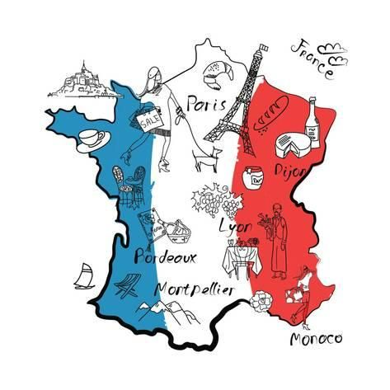](https://www.google.co.uk/url?sa=i&url=https%3A%2F%2Fwww.pinterest.com%2Fpin%2F649081365044371845%2F&psig=AOvVaw2h0i4mbjHo5O2RqEA_s1W5&ust=1614954570930000&source=images&cd=vfe&ved=0CAIQjRxqFwoTCOD-p97slu8CFQAAAAAdAAAAABAK)

**Ensure the teaching and learning of French is of a high standard through a cycle of book scrutinies, lesson observations and pupil interviews.**

**Provide CPD for staff who require support and ensure MFLsubject leaders netweork meetings are attended, gaining expertise from other schools**.

[](https://www.google.co.uk/url?sa=i&url=http%3A%2F%2Fwww.clipartbest.com%2Fsketch-of-eiffel-tower&psig=AOvVaw0UJcZiyI6amrtG5TXjBpyr&ust=1614954783317000&source=images&cd=vfe&ved=0CAIQjRxqFwoTCKis2cPtlu8CFQAAAAAdAAAAABAQ)

**.**

**Ensure pupils are retaining knowledge of French vocabulary through Forget-Me-Not French sessions.**

[